**Lab – 3: How to create a user in Microsoft Azure?**

**Objective:** The objective of this lab is –

* To create a user in Microsoft Azure.

To get things going with Enterprise Mobility + Security you have to add users and assign them licenses in Azure Active Directory. In this lab, I am going to explain you, how to add new users in your organization in the Azure Active Directory or Azure AD one at a time using the Azure portal.

**Prerequisite:** EMS Enterprise Mobility + Security E5 Trial.

**Steps:**

1. Sign in to your Azure Portal, by using the link - https://portal.azure.com/. Enter your credentials and click Sign In.

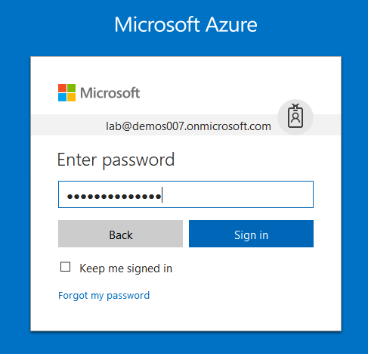

1. Microsoft Azure AD Dashboard will open.

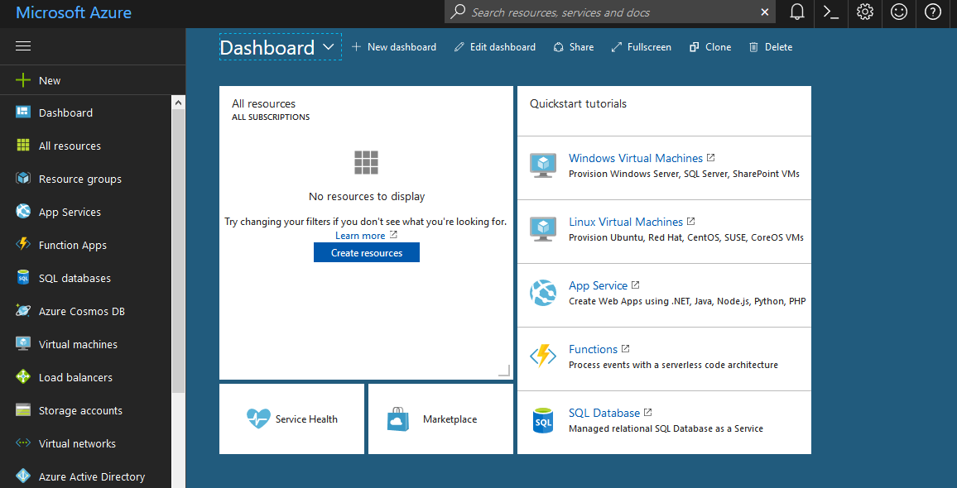

1. Now click **Azure Active Directory** from left-hand pane, and then select **Users and groups**.

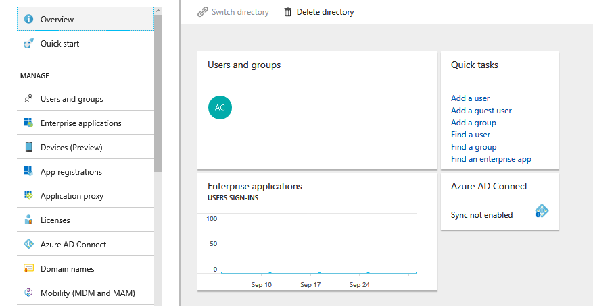

1. On **Users and groups**, select **All users**.

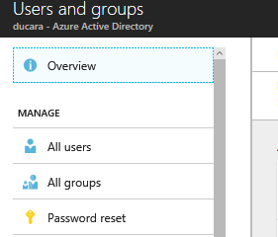

1. And, then select the **New user**, to add a user in Azure Portal.

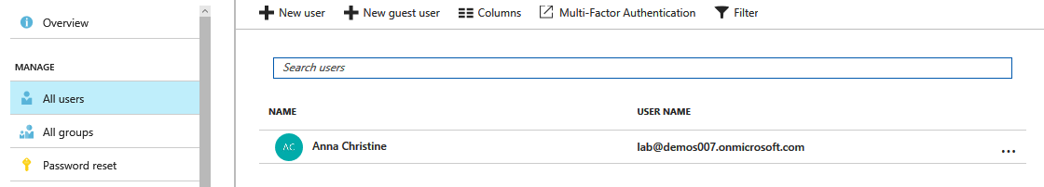

1. Enter details for the user, such as Name and User name. The domain name portion of the user name must either be the initial default domain name **"[domain name].onmicrosoft.com**" or a verified, non-federated custom domain name such as "contoso.com."

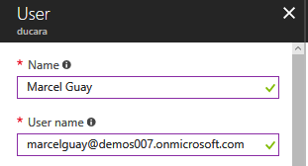

1. Then click **Profile**, to configure the General Profile settings. When you click Profile a Profile Page will open at the right-hand side, where you can fill information. Like – First Name, Last Name, Work Info details. Then click **OK**.

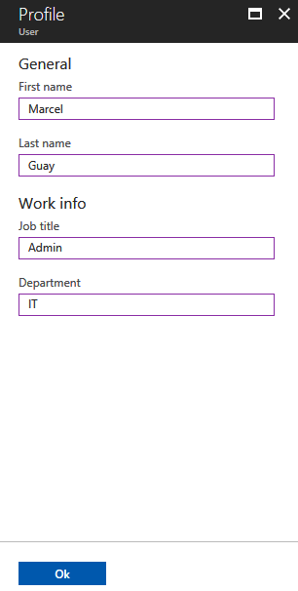

1. Optionally, you can open and fill out the information in **Groups**, or **Directory role** for the user. Here, we are creating a user, so make sure **Directory role** should be **User**.

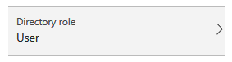

1. Then copy or otherwise note the generated user password so that you can provide it to the user after this process is complete.
2. Now on **User**, select **Create**.

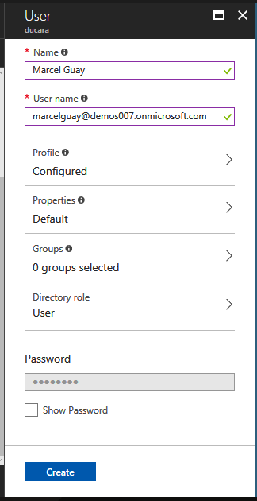

1. Now you can securely distribute the generated password to the new user so that the user can sign in.
2. So, in this way you can create users in Azure AD Portal.